Name: SMIRTI KUMARI

PRN: 1062233392

Division: Third

Class: FY MCA MANAGEMENT

**Web Technology Assignment**

Q2)   Develop PHP Script for the following problems:

1. Write a PHP Script to find out the Sum of the Individual Digits.

**Solution:**

<!DOCTYPE html>

<html lang="en">

<head>

    <meta charset="UTF-8">

    <meta name="viewport" content="width=device-width, initial-scale=1.0">

    <title>Sum of Individual Digits</title>

</head>

<body>

    <h1>Sum of Individual Digits</h1>

    <?php

    // Function to calculate the sum of individual digits

    function sumOfDigits($number) {

        $sum = 0;

        // Iterate through each digit of the number

        while ($number > 0) {

            // Get the last digit of the number

            $digit = $number % 10;

            // Add the digit to the sum

            $sum += $digit;

            // Remove the last digit from the number

            $number = (int)($number / 10);

        }

        return $sum;

    }

    // Check if form is submitted

    if ($_SERVER["REQUEST_METHOD"] == "POST") {

        // Get the input number from the form

        $inputNumber = $_POST["number"];

        // Calculate the sum of individual digits

        $result = sumOfDigits($inputNumber);

        // Display the result

        echo "<p>Sum of individual digits of $inputNumber is: $result</p>";

    }

    ?>

    <!-- Form to input the number -->

    <form method="post" action="<?php echo htmlspecialchars($_SERVER["PHP_SELF"]); ?>">

        <label for="number">Enter a number:</label>

        <input type="number" id="number" name="number" required>

        <button type="submit">Calculate</button>

    </form>

</body>

</html>

**OUTPUT:**

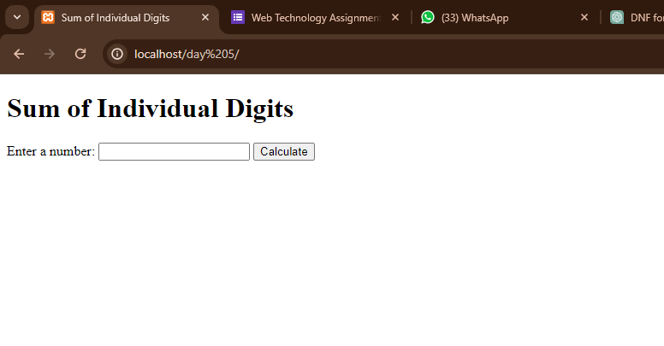

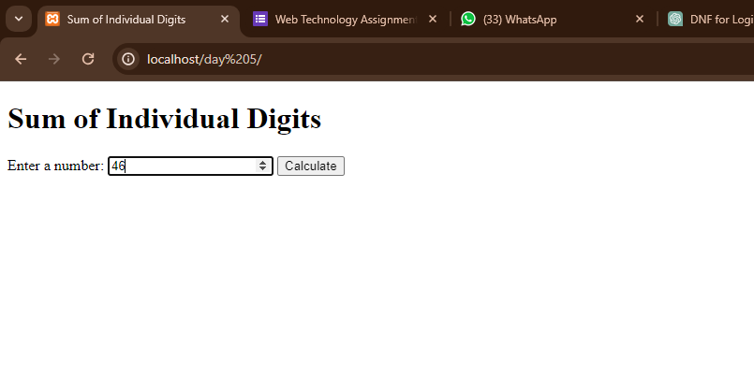

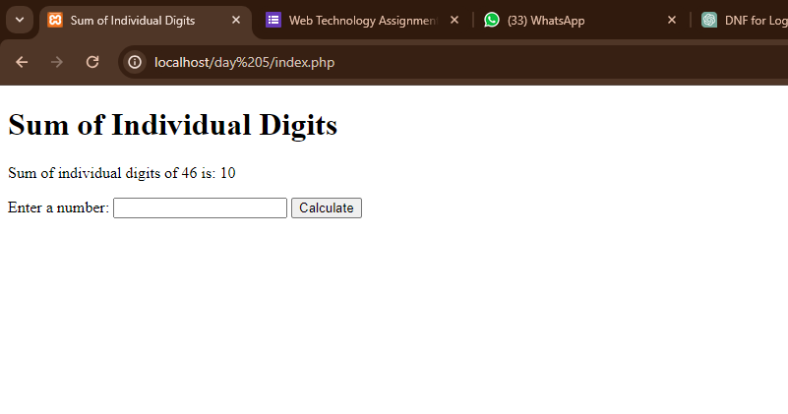

1. Write a PHP Script to check whether the given number is Palindrome or not.

Solution:

<!DOCTYPE html>

<html lang="en">

<head>

    <meta charset="UTF-8">

    <meta name="viewport" content="width=device-width, initial-scale=1.0">

    <title>Palindrome Check</title>

</head>

<body>

    <h1>Palindrome Check</h1>

    <?php

    // Function to check if a number is palindrome

    function isPalindrome($number) {

        // Reverse the number

        $reverse = intval(strrev($number));

        // Check if the original number is equal to its reverse

        if ($number == $reverse) {

            return true;

        } else {

            return false;

        }

    }

    // Check if form is submitted

    if ($_SERVER["REQUEST_METHOD"] == "POST") {

        // Get the input number from the form

        $inputNumber = $_POST["number"];

        // Check if the number is palindrome

        $result = isPalindrome($inputNumber);

        // Display the result

        if ($result) {

            echo "<p>$inputNumber is a palindrome number.</p>";

        } else {

            echo "<p>$inputNumber is not a palindrome number.</p>";

        }

    }

    ?>

    <!-- Form to input the number -->

    <form method="post" action="<?php echo htmlspecialchars($_SERVER["PHP_SELF"]); ?>">

        <label for="number">Enter a number:</label>

        <input type="number" id="number" name="number" required>

        <button type="submit">Check</button>

    </form>

</body>

</html>

**OUTPUT:**

